الجمهورية اللبنانية
الاسم والشهرة:--------------------

رقم المرشح :----------------------
وزارة التربية والتعليم العالي الامتحانات الرسمية لشهادة الامتياز الفني
المديرية العامة للتعليم المهني والتقني لدورة عام 2014 الاولى
===============
الاختصاص والرمز : المعلوماتية الادارية ( 23104)
المادة : برمجة ويب Web المعدل: (8)
المستندات المسموح بها : لا شيء المدة : ساعة ونصف

I- Write the appropriate HTML tags to obtain as result the page " Main1.html" respecting the following conditions (3 pts):  - The author of this page is "Computer".  - The keywords used by search engines are: "Central Unit, CPU, Clock, Bus."  - « Computer Elements » have the font : "verdena", underlined aligned at the center.  - The numbers and the bullets are lists. | 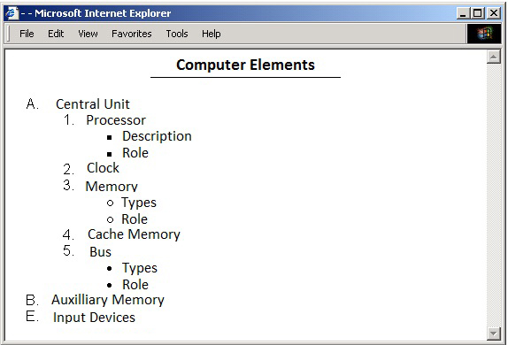
II- Write the appropriate HTML and JAVASCRIPT tags to obtain as a result the following page respecting the following conditions (3 pts):  • The JavaScript function must calculate the salary of an employee and must be called on a click of the button « Calculate ».  • The field « number of hours » cannot contain empty values, the test must be done according to a function when we click outside the field « number of hours » (lost the focus).  • The salary is calculated as follows:  - If the number of hours is less than or equal to 40 then the salary is equal to (number of hours * hourly rate).  - If not the salary is equal to: number of hours * hourly rate – [10% * (number of hours * hourly rate)]. | 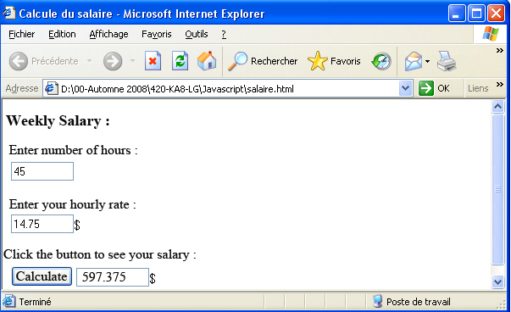
III- Write the page "purchase.html" that allows you to purchase items online. (8 pts)  - This page contains a "form", a text box to enter your name, a combo box to select the item to purchase containing two values "IPhone 5S" and "Samsung-Galaxy 5" and two buttons "Purchase" and "Clear". By pressing the "Purchase" button the information must be sent to the page "order.php" using the "POST" method.  The page "order.php" allows you to purchase an item once a day using a cookie.  - If you want to purchase an "IPhone 5S", after clicking the "Purchase" button, the page "order.php" must access the file "Iphone.txt", read the last value, increment it by 1 and display the number of purchased items of "IPhone 5S" on screen and save it in the file "Iphone.txt". | 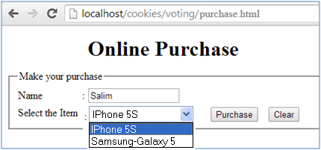  purchase.html
الاختصاص والرمز : المعلوماتية الادارية ( 23104)
المادة : برمجة ويب Web
- If you want to purchase a " Samsung-Galaxy 5", after clicking the "Purchase" button, the page "order.php" must access the file "samsung.txt", read the last value, increment it by 1 and display the number of purchased items of " Samsung-Galaxy 5" on screen and save it in the file "samsung.txt".  - In case you want to purchase more than one item per day, a message "Sorry but you have purchase today the item: ………. you can not make other purchase today”. The value of the purchased item is stored in the cookie already created. | 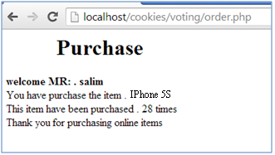  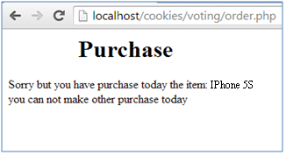  Order.php
IV- Given the database "trade" containing the tables below (6 pts) :  Client Command  ClientId CommandId  Name ClientId  Address Amount  Telephone Date  Write the page "client.php" that allows you to select the name of the client from a combo box and send it to the page "select.php" using the "GET" method when pressing the "Send" button. The data of the combo box "Client Name" are obtained from the field "name" of the table "Client".  The page "select.php" should select all the command information (comandId, Amount, Date) for the selected customer, and display them in a table.  The criteria are as follows:  - The server name is « serverhost ».  - The user name is « user1 ».  - The password is « P@ssw0rd ».  - The database is « trade». | 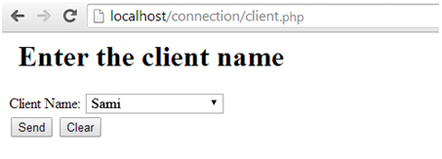  Client.php  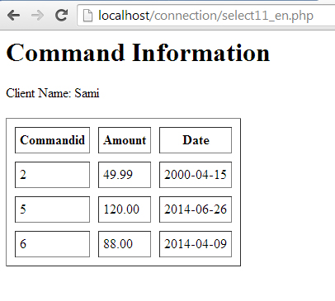  Select.php

